I want to design application for my project. Consider there are following fields
- FieldA
- FieldB
- FieldC
- FieldD
- FieldE
- FieldF

And Want to desing screen like this
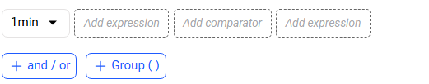

Please dont add 1Min dropdown in design. I dont want that dropdown

Once user click on Expression below screen will appear where instead of options shown in dropdown add above fields. Change label from “Indicators” to “parameter”
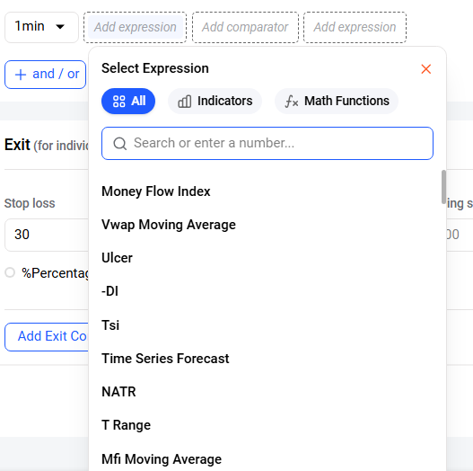

Dont change label of “Math Function” and “All’ option as well.

Once user click of Parameter only display above field
User can filter paramete by typing field name in search box.

Once user click on math function display below options
Min
MAX
FLOOR
ABS
BRACKET
CEIL
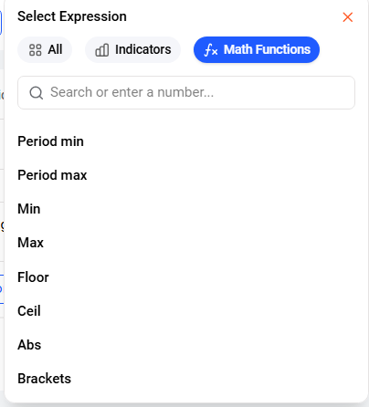

Once user click on All again display all options

Once user click on one of filed that field will get added in Add Expression field along with plus sign

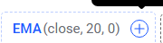

Once user click on plus sign it will add one popup like
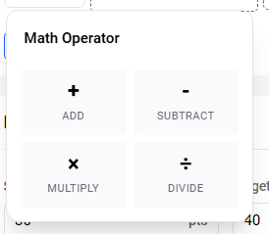

Once use click on one of the math operator again that dropdown will appear containing three option parameter , all , math function like above


In parameter there is one more option call Number

In Paramtere along with above fields there is one more option called “Number”
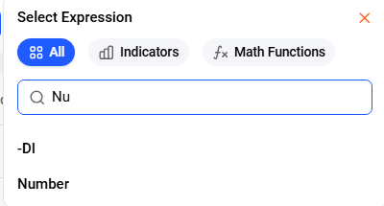

Once user click on Number in Add Expression “0.0” get added

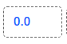

To change number user has to click on 0.0 a popup will appear
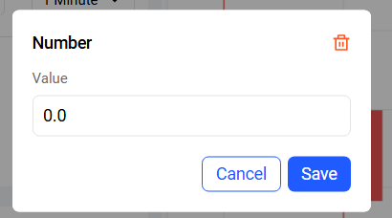

User enter whatever number he has to enter and click on save.

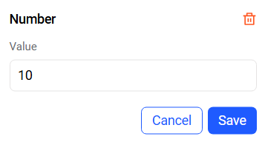

So 0.0 get replaced by 10.0 now



In “Math Function ” label there is one option called Bracket as well once click on bracket Add Expression will get replaced like below
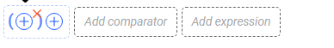

To add fields inside bracket user has to click on plus sign available inside bracket it will again open same dropdown user has to select option from dropdown it will considered as left operand
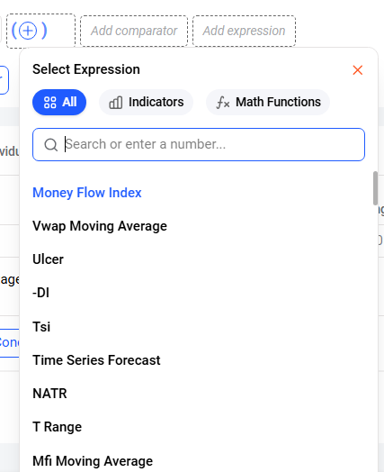

Now second time user

To add operator user has to click on plus sign again operator popup will apear user will select any math operator and it will again add dropdown of parameters
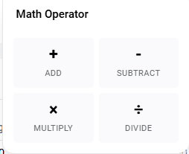
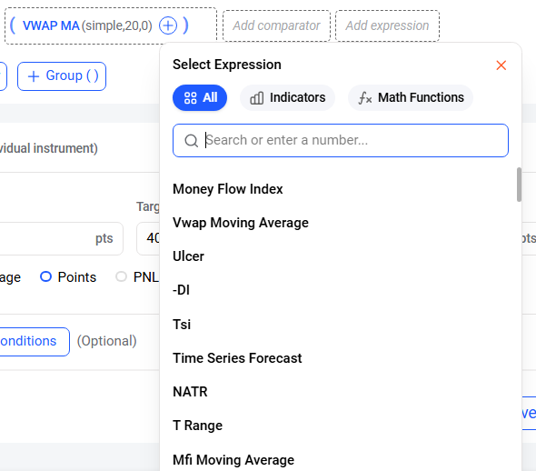

This flow will continue further.

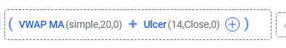
To add more operator and operand plus sign is there.

To add new operator and operand outside bracket there is plus sign outside of bracket
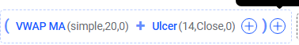

Flow is same for that as well First popup of operator user will select one of the operator and the right side operand from dropdown

Now talk about Add Comparator

Once user click on “Add Comparator” label below popup will appear along with below options
- Equal to
- Lower than
- Lower than equal to
- Higher than
- Higher than equal to

Once user click one of the option that option will get added in “Add Comparator ”

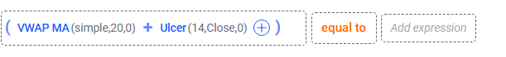

Add expression is same as discuss earlier.

Like this one condition get created
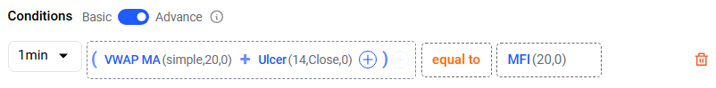

To delete this condition delete bin available it will remove

And display initial screen once again


Once user click on (+ and/or) a new line get added to add condition
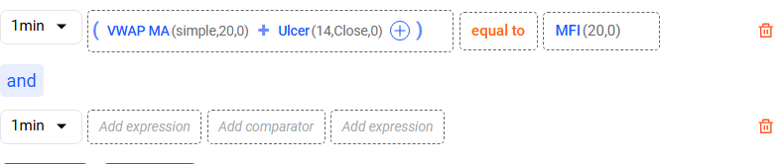

To add “or” condition use has to click on and button once again
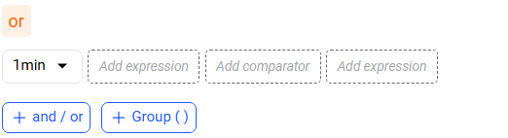

To add again and contion click on or label it is toggle

Group
This will create subgroup condition like this
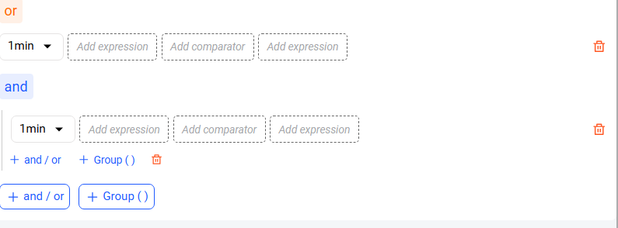

You can create any lavel of subgroup as possible
